

MOI HIGH-KABARAK 2025 PREDICTION
Kenya Certificate of Secondary Education
KCSE PREDICTION SERIES 1
443/2 Agriculture Paper 2
Time: 2 Hours

NAME…………………………………………………………………………………………
SCHOOL……………………………………………… SIGN…………………………..
INDEX NO……………………………………………. ADM NO………………………

Kenya Certificate of Secondary Education.
INSTRUCTIONS TO CANDIDATES:
- Write your name and admission number in the spaces provided.
- Write the date of examination in the spaces provided
- This paper consists of three section A, B and C
- Answer all questions in section A and B
- Answer any two questions in section C

FOR EXAMINERS USE ONLY
SECTION | QUESTIONS | MAX SCORE | CANDIDATES SCORE
A | 1-16 | 30
B | 17-21 | 20
C  TOTAL SCORE | 22-24 | 20
 |  | 20
 |  | 90

SECTION A
Answer all questions
- List three types of calf pens (½ mks)
…………………………………………………………………………………………….............
....................................................................................................................
....................................................................................................................

- Name four breeds of dairy goats . (2mks)
…………………………………………………………………………………………….............
....................................................................................................................
....................................................................................................................
....................................................................................................................

- State three factors that would determine the effectiveness of an acaricide . (1 ½ mks)
…………………………………………………………………………………………….............
....................................................................................................................
....................................................................................................................

- Name one intermediate host for each of the following livestock parasites. (1mk)
- Liver fluke
…………………………………………………………………………………………

- Tape worm
………………………………………………………………………………………

- Give four reasons for feeding a lamb on colostrums . (2mks)
…………………………………………………………………………………………….............
....................................................................................................................
....................................................................................................................
....................................................................................................................

- Differentiate between the following tools.
- Bastrad file and rasp file (1mk)
…………………………………………………………………………………………….............
....................................................................................................................
....................................................................................................................

- Copying saw and hacksaw. (1mk)
....................................................................................................................
....................................................................................................................
....................................................................................................................

- Why are the following conditions maintained during artificial incubation of eggs in poultry production.
- Proper ventilation . (1mk)
....................................................................................................................
....................................................................................................................

- Relative humidity at 60% (1mk)
…………………………………………………………………………………………….............
....................................................................................................................

- State any four functions of proteins in animals . (2mks)
…………………………………………………………………………………………….............
…………………………………………………………………………………………….............
....................................................................................................................
....................................................................................................................

- Give two factors that would affect digestibility of a given feedstuff in livestock. (1mk)
…………………………………………………………………………………………….............
....................................................................................................................

- Mention two methods of carrying out bloodless castration in a calf . (1mk)
…………………………………………………………………………………………….............
…………………………………………………………………………………………….............
....................................................................................................................

- Give four reasons why flushing is encouraged in sheep production. (2mks)
…………………………………………………………………………………………….............
…………………………………………………………………………………………….............
....................................................................................................................
....................................................................................................................
....................................................................................................................

- Name four breeds of rabbit reared for meat production in Kenya. (2mks)
…………………………………………………………………………………………….............
…………………………………………………………………………………………….............
....................................................................................................................
....................................................................................................................
....................................................................................................................

- State two functions of water in the body of an animals . (1mk)
…………………………………………………………………………………………….............
…………………………………………………………………………………………….............
....................................................................................................................

- State two predisposing factors for mastitis in dating cattle. (1mk)
…………………………………………………………………………………………….............
…………………………………………………………………………………………….............
....................................................................................................................

- State four maintenance practices tat should be carried out on an axe. (2mks)
…………………………………………………………………………………………….............
....................................................................................................................
....................................................................................................................
....................................................................................................................

- State four factors that influence quality of honey . (2mks)
…………………………………………………………………………………………….............
…………………………………………………………………………………………….............
....................................................................................................................
....................................................................................................................
....................................................................................................................

- List down three characteristics of succulent roughage for livestock feeding . (1½ mks)
…………………………………………………………………………………………….............
....................................................................................................................
....................................................................................................................

- State three possible measures for controlling liver flukes infestation in a livestock form . (1½ mks)
…………………………………………………………………………………………….............
....................................................................................................................
....................................................................................................................

- Give two reasons why jersey breed of cattle is better suited to marginal areas than freshian
…………………………………………………………………………………………….............
....................................................................................................................
....................................................................................................................

SECTION B
- The diagram below illustrates the digestive system of a chicken . Study it carefully and answer the questions that follows.
- Name the labeled A,BC, D E and F (3mks)
A……………………………………………………………………………
B…………………………………………………………………………..
C…………………………………………………………………………..
D…………………………………………………………………………..
E……………………………………………………………………………..
F……………………………………………………………………………….

- State one function for each of the parts labeled A,B and C (3mks)
A………………………………………………………………………………………
B………………………………………………………………………………………
C……………………………………………………………………………………….

- Give one reason why chickens are fed with insoluble grit. (1mk)
…………………………………………………………………………………………….............
....................................................................................................................

- What is the special function of part labeled D in the diagram above. (1mk)
…………………………………………………………………………………………….............
....................................................................................................................

- The diagrams E,F and G illustrates various workshop tools . Study them and answer the questions that follow.
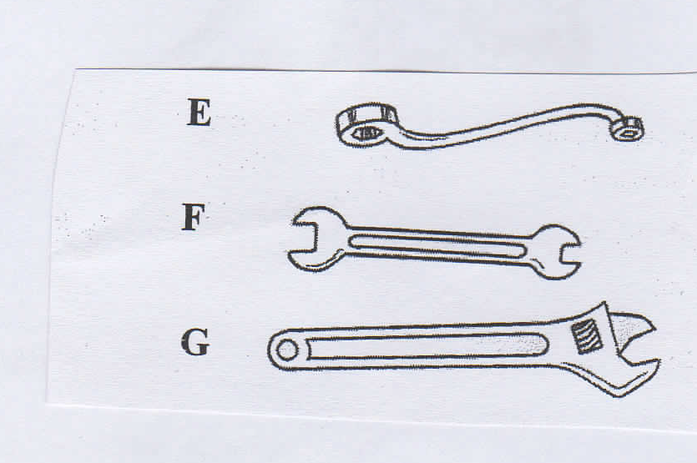
- Identify the tools labeled E,F and G shown above. (3mks)
E………………………………………………………………
F………………………………………………………………
G…………………………………………………………….

- Give two functional differences between tool F and G (2mks)
…………………………………………………………………………………………….............
....................................................................................................................
....................................................................................................................
....................................................................................................................

- State two maintenance practice that should be carried out on the tool labeled. (2mks)
…………………………………………………………………………………………….............
....................................................................................................................
....................................................................................................................

- The following diagram illustrates a symptom of a disease in poultry. Study it carefully and answer the questions that follow.
- Identify
- The disease (½ mk)
- The causal organism (½ mk)
- A part from lesions . State two other symptoms of the disease (2mks)

- State two control measures for the disease. (2mks)

SECTION C
- Describe the feeding practices carried out on a calf from birth to weaning. (10mks)
- Describe management practices that would ensure clan milk production in a dairy farm.(10k)

- a.i) Describe four functions of a gearbox. (4mks)
ii)State four factors to consider when selecting materials for constructing a calf pen . (4mks)
iii)Give four maintenance practices that should be carried out on permanent calf pen. (4mks)
b)State factors considered when culling livestock. (8mks)
25.a) State five control measures of cannibalism (8mks)
b) Describe five conditions brought about by mineral deficiency. (6mks)
c) Outline disadvantages of animal draw impliments as compared to tractor drawn impliments. (6mks)

